

**3rd Year Project Proposal**

**Student Name:** Jordan O Loughlin, Elijah Omotosho, Thomas Jones

**Student Number:** K00233561, K0023, K00232078

**Programme:** Games Design and Development Y3

**Working Title:** “...But Better”

**Description:** Complete Puzzles to collect a key to exit. Players must travel through a maze and solve a puzzle to get a key to escape to freedom. Enemies travel the maze to interfere with you. Players can pick up power ups, e.g. weapons, visibility, speed, defence. Play against time to get on the leader board. Android platform utilising the sensors in the phone. The phone is going to be the main controller.

The maze itself takes a different approach than the usual by using circular mazes instead of traditional square mazes. Not only this there will be a limited visibility for the player, giving incentive for the players to collect the power ups. We also plan on keeping the graphics to a more old-school, 2.5d look and feel; similar to Zelda: A Link to the Past, or Stardew Valley.

The player will travel through the labyrinth and at the very end there will be a puzzle to solve, that will advance you to the next level upon completion or provide you with a key. The player would then have to search the maze for the door that the key goes to, and then progresses to the next level.

**Reasons for selecting project:** Wanted to try implementing android capabilities and a mix of Zelda and Stardew Valley style visuals to create a maze game, that is fun and unique. We chose a maze genre as we will be making this our entry into Games Fleadh 2020.

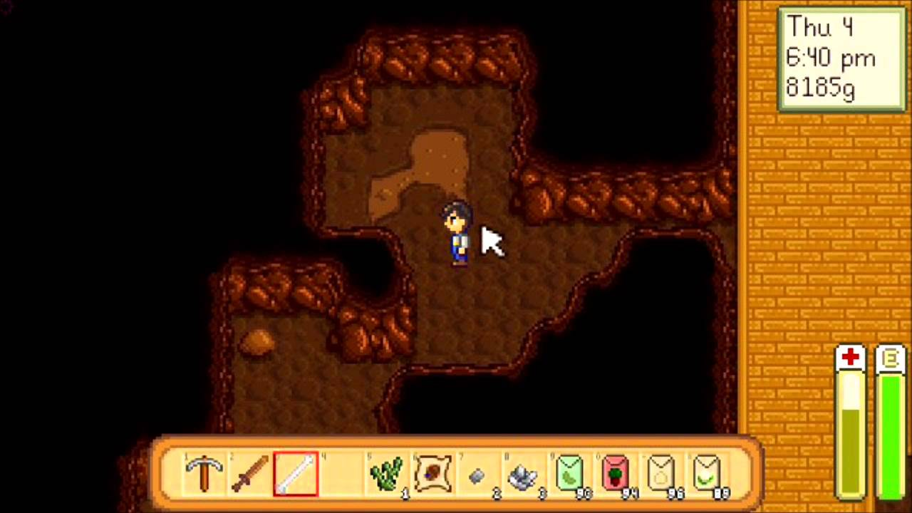

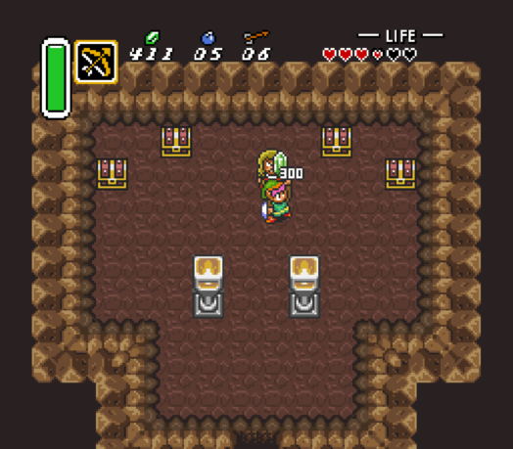

**Proposed research content:** Link to the Past, Stardew Valley, Android Maze Games on the play store, Accelerometer and other android features. Android API, porting from SFML to android/google play.

External links (if applicable):

<https://www.sfml-dev.org/documentation/2.5.1/>

<https://developer.android.com/reference/packages>

Hardware requirements: Phone with Sensors

Software requirements: Android SDK, Android Studio

Signed:

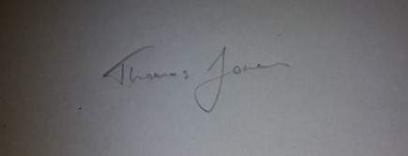

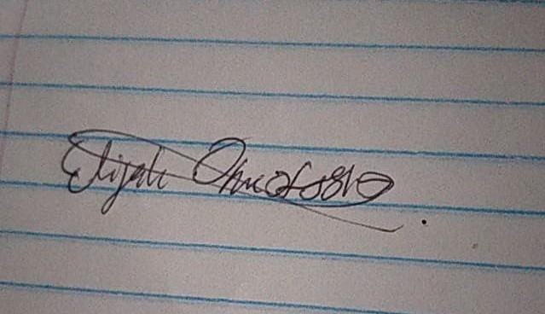

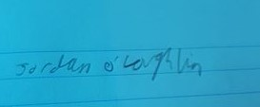

Date:

**For Office Use Only**

Approved/Not Approved: _________________________________

Reasons for not approving project: _______________________________________________________________________________________________________________________________________________________________________________________________________________

Conditions attached to approving project: _______________________________________________________________________________________________________________________________________________________________________________________________________________

Name of supervisor: ____________________________________________________

Signed: _____________________________ Date: __________________